VSCA Subscriber Manager
User Guide

Vintage Snowmobile Club of America
Subscriber & Membership Management System
Version 1.0

Table of Contents
1. Introduction 4
1.1 Purpose of This Guide 4
1.2 System Requirements 4
2. Getting Started 5
2.1 Launching the Application 5
2.2 Logging In 5
3. Main Window Overview 6
3.1 Subscriber List (Left Panel) 6
3.2 Subscriber Details (Right Panel) 6
3.3 Toolbar 6
4. Viewing Subscriber Details 8
4.1 Personal Details Tab 8
4.2 Notes Tab 9
5. Searching for Subscribers 10
5.1 Search Fields 10
5.2 Performing a Search 10
6. Creating a New Subscriber 11
6.1 Filling in the Form 11
6.2 Saving the New Subscriber 12
7. Editing Subscriber Information 13
7.1 Editing Personal Details 13
7.2 Editing Subscription Details 13
7.3 Editing Notes 13
8. Renewing a Subscription 15
8.1 How to Renew 15
8.2 Understanding Issue Calculations 15
9. Deleting a Subscriber 16
9.1 How to Delete 16
10. Importing Subscribers from CSV 17
10.1 Running an Import 17
10.2 CSV Format 17
11. Managing Contests 18
11.1 Starting a Contest 18
11.2 Stopping a Contest 18
12. Keyboard Shortcuts & Tips 19
12.1 General Tips 19
13. Troubleshooting 20
13.1 Cannot Log In 20
13.2 Subscriber List is Empty 20
13.3 Renewal Does Not Update Correctly 20
13.4 Import Fails or Produces Unexpected Results 20

1. Introduction
The VSCA Subscriber Manager is a desktop application designed to help manage subscriber records for the Vintage Snowmobile Club of America. It provides a central database for storing and maintaining subscriber contact information, subscription details, renewal history, and special account flags such as contest eligibility and manual mailing.

1.1 Purpose of This Guide
This guide walks you through every feature of the VSCA Subscriber Manager, from logging in for the first time to managing contests and importing subscriber data. Step-by-step instructions are provided for all common tasks, along with field reference tables and tips throughout.

1.2 System Requirements
The following are required to run the VSCA Subscriber Manager:
- Windows operating system (Windows 10 or later recommended)
- Access to a SQL Server instance (local or network)
- Valid database credentials (username and password)

NOTE: If this is your first time launching the application, the database will be created automatically when you log in. No manual database setup is required.

2. Getting Started

2.1 Launching the Application
Double-click the VSCA Subscriber Manager shortcut on your desktop or locate the application executable and launch it. The Login window will appear.
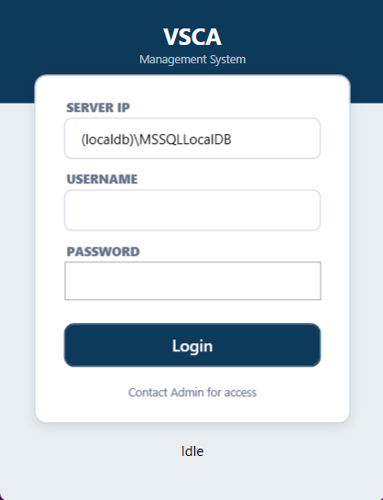
[Screenshot: Login Window]

2.2 Logging In
The Login window contains three fields you must fill in before connecting to the database:

Field | Description
Server IP | The IP address or hostname of your SQL Server. Defaults to (localdb)\MSSQLLocalDB. Change this if connecting to a networked server.
Username | Your SQL Server login username (not needed for localdb).
Password | Your SQL Server login password (not needed for localdb).

To log in:
- Confirm the Server IP is correct for your environment.
- Enter your Username and Password.
- Click the Login button.

TIP: If this is the first time the application has been run against this database, it will automatically create and initialize the required tables. This may take a few moments.

3. Main Window Overview
After a successful login, the Main Window opens. This is the central hub of the application where you can browse, search, view, and manage all subscriber records.
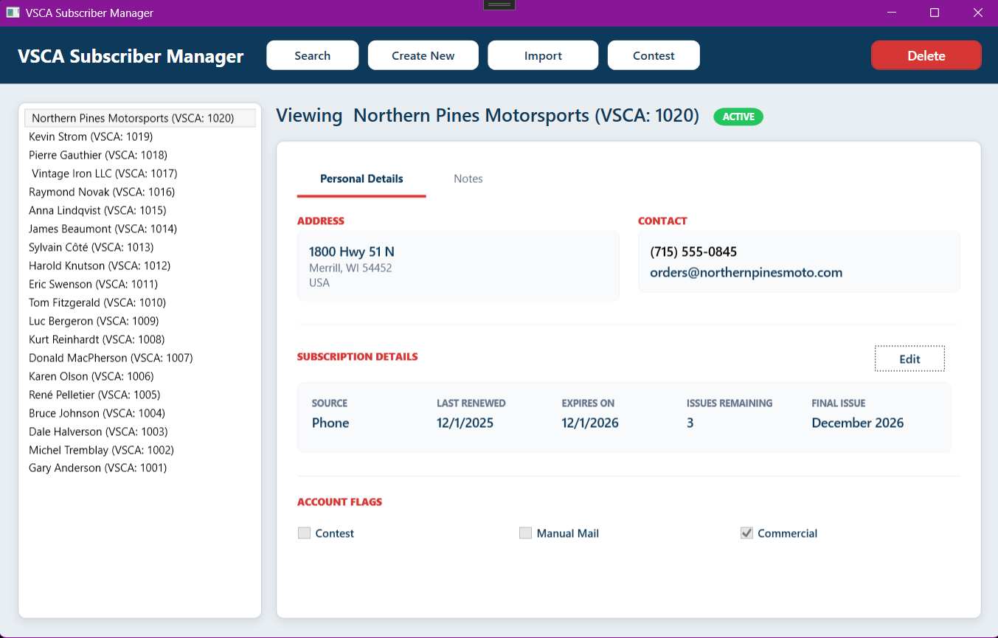
[Screenshot: Main Window — Full Layout]

3.1 Subscriber List (Left Panel)
The left side of the window contains a scrollable list of all subscribers currently in the database. Each entry shows the subscriber's name and VSCA number. Clicking a subscriber in this list loads their full details in the right panel.

TIP: Use the Search feature to filter this list by name, phone, or VSCA number when you need to quickly locate a specific subscriber.

3.2 Subscriber Details (Right Panel)
When a subscriber is selected, their information is displayed in the right panel, organized into two tabs:
- Personal Details — displays address, contact information, subscription information and status.
- Notes — displays any free-form notes associated with the subscriber.

3.3 Toolbar
The toolbar at the top of the window provides quick access to the main actions:

Field | Description
Create New | Opens the subscriber creation form to add a new subscriber to the database.
Search | Opens the Search window to filter the subscriber list.
Import | Imports subscriber records from a CSV file.
Contest | Opens the Contest management window.
Delete | Deletes the currently selected subscriber (requires confirmation).

4. Viewing Subscriber Details
To view a subscriber's details, click their name in the subscriber list on the left. The right panel will populate immediately with their information.
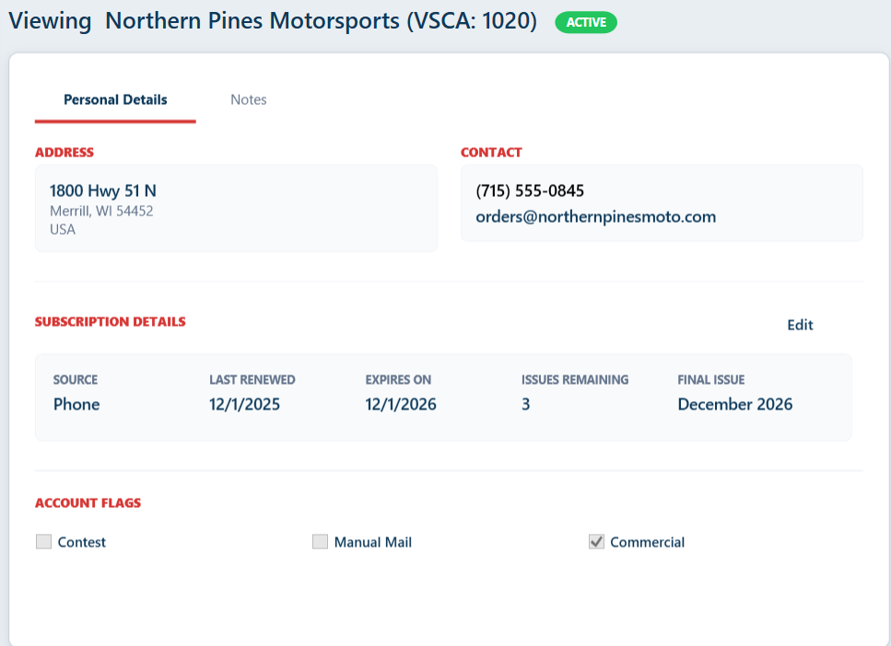
[Screenshot: Subscriber Details — Personal Details Tab]

4.1 Personal Details Tab
The Personal Details tab displays all contact and subscription information for the selected subscriber:

Field | Description
VSCA # | The subscriber's unique VSCA identifier.
Name | First and last name.
Phone | Contact phone number.
Email | Contact email address.
Address | Street address, city, region, postal code, and country.
Renewal Date | The date the subscription was last renewed.
Expiration Date | The date the subscription expires.
Source | How the subscriber was acquired (e.g., direct, referral).
Issues Remaining | The number of magazine issues left on the subscription.
Final Issue | The calculated issue (March / June / September / December) on which the subscription ends.
Active | Whether the subscriber's account is currently active.
Contest | Whether the subscriber is marked as a contest participant.
Manual Mail | Whether this subscriber receives mail manually outside the normal distribution.
Commercial | Whether this is a commercial account.

4.2 Notes Tab
The Notes tab displays any free-text notes stored against the subscriber's record. Notes can be up to 500 characters long and are useful for storing reminders, special instructions, or background information.
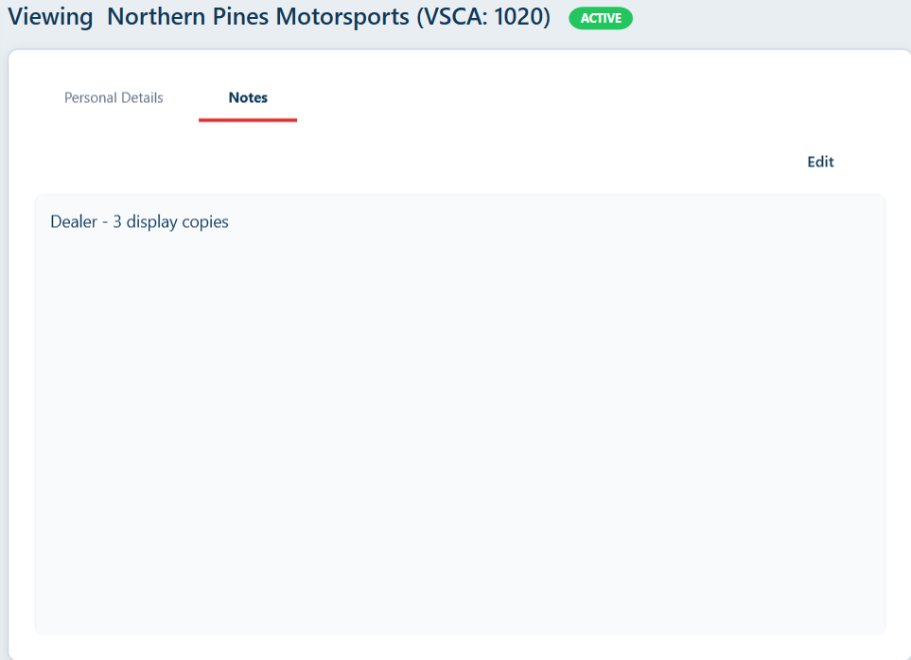
[Screenshot: Subscriber Details — Notes Tab]

5. Searching for Subscribers
When the subscriber list is large, use the Search function to quickly locate records. Click the Search button in the toolbar to open the Search window.
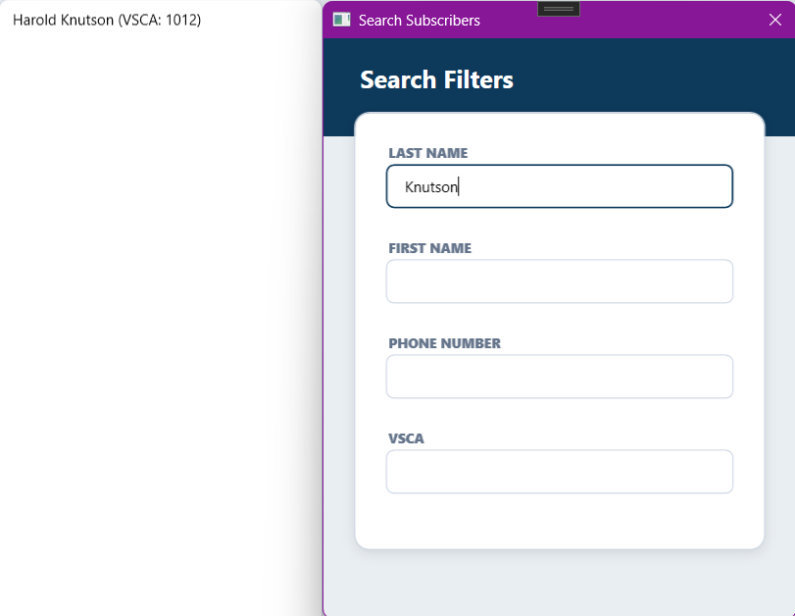
[Screenshot: Search Window]

5.1 Search Fields
You can search using any combination of the following fields:

Field | Description
Last Name | Filters subscribers whose last name matches or contains the entered text.
First Name | Filters subscribers whose first name matches or contains the entered text.
Phone Number | Filters by phone number.
VSCA # | Filters by the subscriber's unique VSCA number.

5.2 Performing a Search
- Click the Search button in the toolbar.
- Enter your search criteria in one or more fields.
- The subscriber list on the main window updates in real time as you type.
- Click a result in the list to view that subscriber's details.
- To return to the full list, click the Clear Search button.

TIP: You do not need to fill in all search fields. Entering just a last name, for example, is enough to narrow down the list.

6. Creating a New Subscriber
To add a new subscriber to the database, click the Create New button in the toolbar. The subscriber creation form will open.
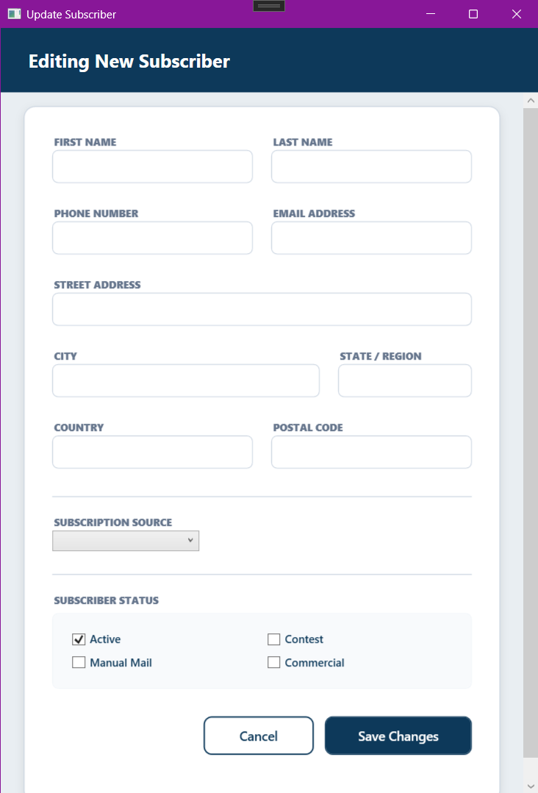
[Screenshot: Create / Edit Subscriber Form]

6.1 Filling in the Form
Complete the subscriber details form with the new subscriber's information. The following fields are available:

Field | Description
First Name | The subscriber's first name.
Last Name | The subscriber's last name.
Phone | Contact phone number.
Email | Contact email address.
Street | Street address.
City | City.
Region | State, province, or region.
Postal Code | ZIP or postal code.
Country | Country.
Source | Select how the subscriber was acquired from the dropdown list.
Active | Check to mark the account as active.
Contest | Check if the subscriber is a contest participant.
Manual Mail | Check if the subscriber requires manual mailing.
Commercial | Check if this is a commercial account.

6.2 Saving the New Subscriber
- Fill in all required information.
- Click Save to create the subscriber record.
- You will be prompted to set up the subscriber's initial subscription via the Renewal window (see Section 8).
- The new subscriber will appear in the subscriber list immediately.

NOTE: Clicking Cancel at any point will discard all entered information and close the form without saving.

7. Editing Subscriber Information
You can edit both personal details and subscription information for any subscriber.

7.1 Editing Personal Details
- Double click a subscriber from the list.
- The form fields become editable. Make your changes.
- Click Save to commit the changes, or Cancel to discard them.
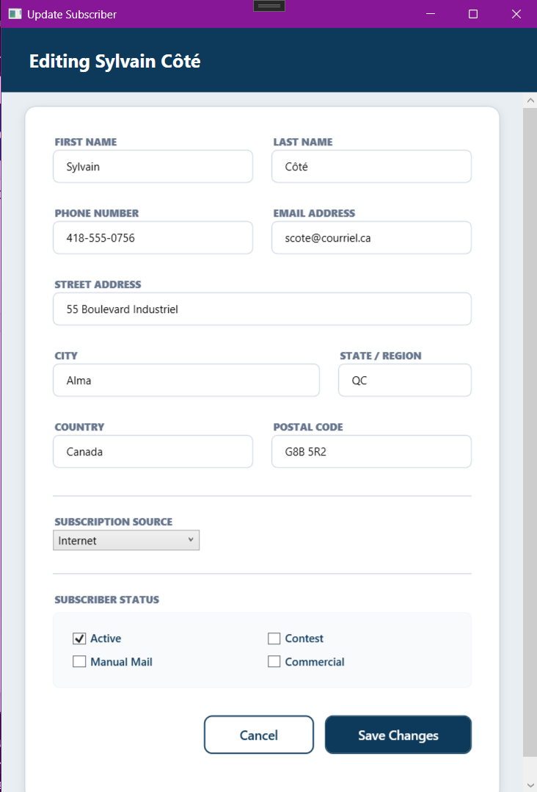
[Screenshot: Edit Mode — Personal Details]

7.2 Editing Subscription Details
Subscription-specific fields (renewal date, expiration date, source, and issues remaining) can also be updated directly from the Personal Details tab:
- Select the subscriber from the list.
- Click the Edit button in the Subscription Details section.
- Modify the relevant fields.
- Click Save to commit, or Cancel to discard.

TIP: To renew a subscription and automatically extend the expiration date and issues remaining, use the dedicated Renew function described in Section 8.

7.3 Editing Notes
- Select the subscriber and click the Notes tab.
- Click the Edit button.
- A text box appears. Type or modify the notes (up to 500 characters).
- Click Save to store the notes, or Cancel to discard changes.
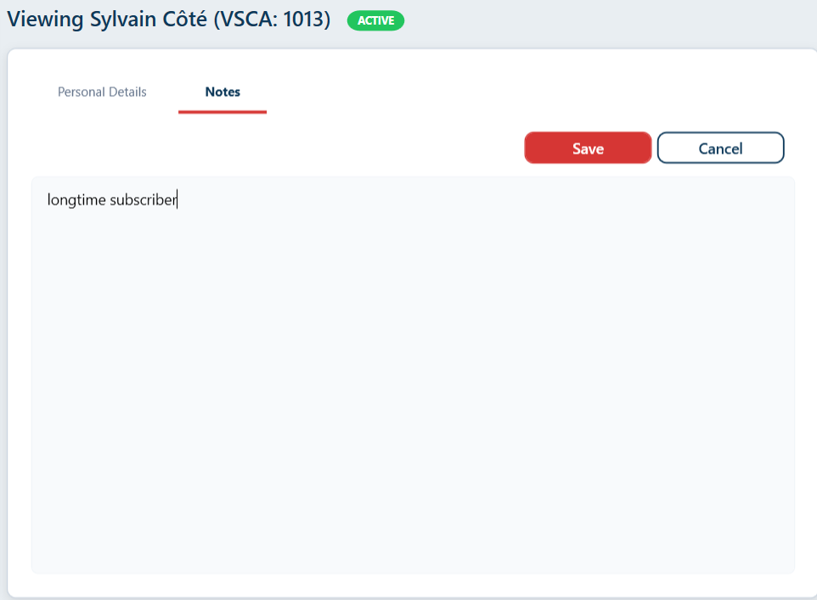
[Screenshot: Edit Mode — Notes Tab]

8. Renewing a Subscription
The Renew function allows you to extend a subscriber's subscription quickly and accurately. Renewal automatically recalculates the expiration date and updates the number of issues remaining.
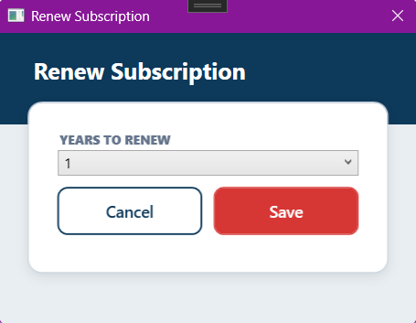
[Screenshot: Renewal Window]

8.1 How to Renew
- Select the subscriber from the list.
- In the Subscription Details section, click Edit, then click Renew.
- The Renew window opens. Select the renewal period: 1 year, 2 years, or 3 years.
- Click Confirm. The system will update the subscriber's record as follows:
  - If expiration date is in the future, add 1/2/3 years to that date (ex. It is May 1st 2026. Current subscription expires on June 1st 2026. Renewing for 1 year would make the new expiration date June 1st 2027)
  - If expiration date is in the past (or a new subscriber), add 1/2/3 years to current date (ex. It is May 1st 2026. Renewing for 1 year would make the new expiration date May 1st 2027)
  - Issues Remaining increases by 4 for each year renewed.
  - If a contest is currently active, the subscriber will be automatically flagged as a contest participant.
- Click Save in the edit view to persist the changes.

8.2 Understanding Issue Calculations
Issues are published quarterly in March, June, September, and December. The Final Issue field is automatically calculated based on the expiration date and the publication cutoff date (the 10th of the month prior to each issue).

NOTE: Renewing for 2 years adds 8 issues; renewing for 3 years adds 12 issues. The expiration date is calculated from the current expiration date, not today's date.

9. Deleting a Subscriber
Subscribers can be permanently removed from the database. This action cannot be undone, so a confirmation prompt is shown before deletion proceeds.

9.1 How to Delete
- Select the subscriber you wish to remove from the list.
- Click the Delete button (highlighted in red) in the top-right area of the toolbar.
- A confirmation dialog will appear asking you to verify the deletion.
- Click Confirm (or Yes) to permanently delete the record.
- The subscriber will be removed from the list immediately.

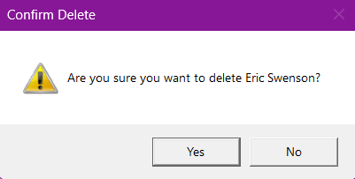
[Screenshot: Delete Confirmation Dialog]
WARNING: Deleting a subscriber is permanent. There is no undo. Verify you have selected the correct subscriber before confirming.

10. Importing Subscribers from CSV
The Import feature allows you to load subscriber records in bulk from a CSV (comma-separated values) file. This is useful for initial data loads or migrating records from another system.

10.1 Running an Import
- Click the Import button in the toolbar.
- A file browser dialog opens. Navigate to and select your CSV file.
- Click Open. A progress window will appear while the file is being processed.
- Once complete, the subscriber list will refresh to include all newly imported records.

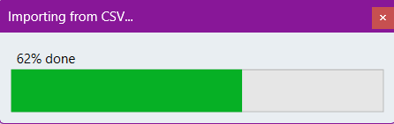
[Screenshot: Import Progress Window]

10.2 CSV Format
The CSV file must match the expected column structure for the import to succeed. Ensure in your file that each column aligns with the corresponding subscriber fields (name, address, phone, email, subscription details, etc.).

TIP: If an imported record matches an existing VSCA number, the existing record will be updated rather than duplicated.

11. Managing Contests
The Contest feature allows you to run a promotional contest for a defined period. When a contest is active, any subscriber who renews their subscription during that period is automatically flagged as a contest participant.
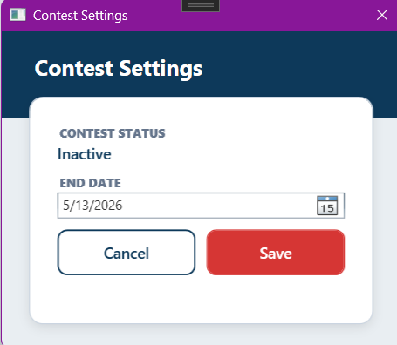
[Screenshot: Contest Management Window]

11.1 Starting a Contest
- Click the Contest button in the toolbar.
- The Contest window opens showing the current contest status (Active or Inactive).
- If no contest is active, enter the contest end date in the provided field.
- Click Save. The contest is now active.

11.2 Stopping a Contest
- Click the Contest button in the toolbar.
- The Contest window shows the current end date and an Active status.
- Click the Stop button.
- The contest is deactivated. Subscribers who renewed during the contest period will retain their contest flag.

NOTE: While a contest is active, any renewal processed through the Renew window (see Section 8) will automatically mark the subscriber as a contest participant.

12. Keyboard Shortcuts & Tips
The following keyboard shortcuts are available throughout the application:

Field | Description
ESC | Deselects the currently selected subscriber, or cancels the current edit mode if one is active.

12.1 General Tips
- Always click Save after making changes. Closing a window without saving will discard any unsaved edits.
- The subscriber list updates in real time when you use the Search window. You do not need to close Search to view results.
- The Final Issue field is calculated automatically. You do not need to set it manually.
- The Contest flag on a subscriber record is set automatically during renewal when a contest is active. You can also set or clear it manually by editing the subscriber.
- For large imports, allow the progress window to complete before interacting with the application.

13. Troubleshooting

13.1 Cannot Log In
- Verify the Server IP address is correct. If connecting to a local database, this should be 127.0.0.1 or localhost.
- Confirm your username and password are correct.
- Ensure the SQL Server service is running on the target machine.
- Check that your network connection is active if connecting to a remote server.

13.2 Subscriber List is Empty
- If this is a new installation, no subscribers have been added yet. Use Create New or Import to populate the database.
- Check whether a search filter is active. Click Clear Search to return to the full list.

13.3 Renewal Does Not Update Correctly
- Ensure you click Save after completing the renewal. Changes are not persisted until saved.
- Verify the original expiration date is set correctly before renewing. Renewal extends from the existing expiration date.

13.4 Import Fails or Produces Unexpected Results
- Verify your CSV file uses the correct column structure and includes a valid header row.
- Ensure the file is saved as plain CSV (not Excel .xlsx format) before importing.
- Check for any special characters or encoding issues in the source file.

SUPPORT: If you continue to experience issues, contact your system administrator or the developer who set up the application.

